National University of Computer and Emerging Sciences



Lab Manual 07

Object Oriented Programming

|  |  |
| --- | --- |
| Course Instructor | Mr. Waqas Manzoor |
| Lab Instructor (s) | Mr. Dilawar Shabbir |
| Section | BSE-2C |
| Semester | Spring 2022 |

Department of Computer Science

FAST-NU, Lahore, Pakistan

## 

## Objectives

After performing this lab, students shall be able to:

* Stream insertion and extraction operator
* Relational operators
* Dynamically allocate and deallocate memory

**Instructions**

* Make sure memory is deallocated properly
* implement the functions outside the class
* Make appropriate functions if you need them.

**Task 01:**

Given **N** triangles along with the length of their three sides as **a, b and c**. The task is to count the number of unique triangles out of these **N** given triangles. Two triangles are different from one another if they have at least one of the sides different.

**Example input and output:**

***Input:****arr[] = {{3, 1, 2}, {2, 1, 4}, {4, 5, 6}, {6, 5, 4}, {4, 5, 6}, {5, 4, 6}};* ***Output:****3*

***Input:****arr[] = {{4, 5, 6}, {6, 5, 4}, {1, 2, 2}, {8, 9, 12}};* ***Output:****3*

**NOTE:**

Use the [operator overloading](https://www.geeksforgeeks.org/operator-overloading-c/) based approach to solve this problem where we are going to overload the relational operator **(==)**of our class.

**Task 02:**

Given two matrix **mat1[][]** and **mat2[][]** of NxN dimensions, the task is to perform [Matrix Operations](https://www.geeksforgeeks.org/different-operation-matrices/) using [Operator Overloading](https://www.geeksforgeeks.org/operator-overloading-c/).

**Example:**

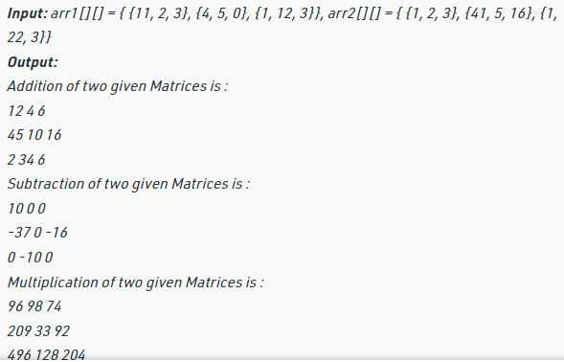

**Task 03:**

A decimal number is composed of an integral part and a fractional part. The number appearing before the decimal point is the integral part while the number appearing after the decimal point is called the fractional part. For example if our number is 1.2 then 1 is the integral part while 2 is the fractional part. Using this concept develop the following class. Your task is to overload the prefix and postfix increment operators for a class called roundoff. The roundoff class has a floating point data member called number. Overload the operators as follows

* Overload the stream insertion and extraction operators to input/ output the data.
* Prefix increment – When this operator is called there will be an increment in the integer part of the number. For example if our original number is 3.5 then after prefix increment the result will be 4.5
* Postfix increment - When this operator is called there will be an increment in the fractional part of the number. For example if our original number is 3.5 then after postfix increment the result will be 3.6.

**Task 04:**

Given two strings, how to check if the two strings are equal or not, using Operator Overloading.

Example:

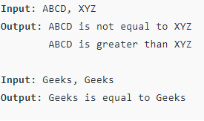

**END**